**Pw skills – pandas Imp notes**

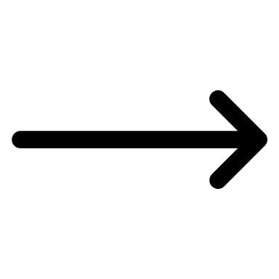**1:- groupby function:**

Group function categorize your data set in to categorical values , with this categorical values we can analyse the statistical summary of our data set

**For example :-**

**2:Rolling Function**

**Rolling function is a function which is used for statistical analysis over a particular window or a data , For example If I have data which consists of date and sales means during that day how much sales were been there for particular product.**

**This function is used on series and data frame , it syntax is df.rolling()**

**There are many parameters which comes under rolling function some are given below.**

**window:** This parameter specifies the size of the window over which the calculation will be performed. It determines the number of consecutive elements to include in each window. For example, setting window=7 means that the calculation will be done over a window of 7 elements**.**

**min_periods:** This parameter specifies the minimum number of non-null values required in the window to compute a valid result. It determines the minimum number of elements needed for the calculation. By default, it is set to None, which means all elements in the window must be non-null for a valid result. However, you can set it to a value less than window to compute results with fewer elements.

**Other parameters:** The rolling() function supports additional parameters such as center, win_type, and on. These parameters control the centering of the window, the window type, and the column on which the operation will be performed, respectively.

**The rolling() function returns a Rolling object that provides access to various statistical and aggregation methods such as mean(), sum(), max(), min(), etc. These methods can be applied to the Rolling object to calculate statistics over the defined window.**

**3:-day_name()**

**day_name function is a function which is used for finding the weekdays values according to the date , for example If I have date column then and I want to find the days then by day name function we can find it this will basically return the series of weekdays according to the date**

**Imp condition :-**

**First convert the date column to datetime values by pd.to_datetime(df[“date”]). Keep this in a variable and pass this variable to the function which is used for coverting the date to weekdays, so pass dataframe and this variable both in it after that**

**Then , use day name function in new column of weekdays example df[“weekdays”]=date.dt.day_name()**

**4:- Index function:-**

**Index function is used for allocating the indexes to data frames , there are many types of indexes function.**

**1:-set_index**

**2:-reset_index**

**3:-index**

**4:-reindex**

**1:-set_index function is used for setting the new index to the data frameby giving the column _name for example**

**Df.set_index(“column_1”)**

**2:-reset_index function is used for setting the default indesx to the data frame**

**3:-index function is used for setting the index to the data frame during the beginning of data frame**

**Reindex:_ in reindex we can change the index numbers according to our own for example**

**Df.reindex([1,2.4,3])**

**5:- Iterrrowsz(), iteritems(),ittertuples() function : This function is used for displaying the data from the data frame. This function generates an object , and after if we iterate this object with the loop then it will give the desired result.**

**Iterrows():- This function basically generates the rows data entirely with the rows index**

**For example;-**

**\**

**2:-Itertuples():- This function generates the tuples by giving the index of the row with column with its values for example**

**3:-iteritems():- This function basically generates the rows data entirely with the column index**

**For example:-**

**6th:-applymap:- applymap is a function which is used for mapping the function with each value in a dataframe**

**For example:-**

**7th:-setoption:- this function is used for displaying the width of data inside the data frame by giving the width of our won choice**

**For example:-**

**8:-sort_values():-This function is used for sorting the values either in order (ascending or descending order).**

**For example:**

**Sort_index :- this function is used to sort the index of the data frame**

**For example:**

**To_datetime() this function is used for converting the string type or object to datetime data type.**

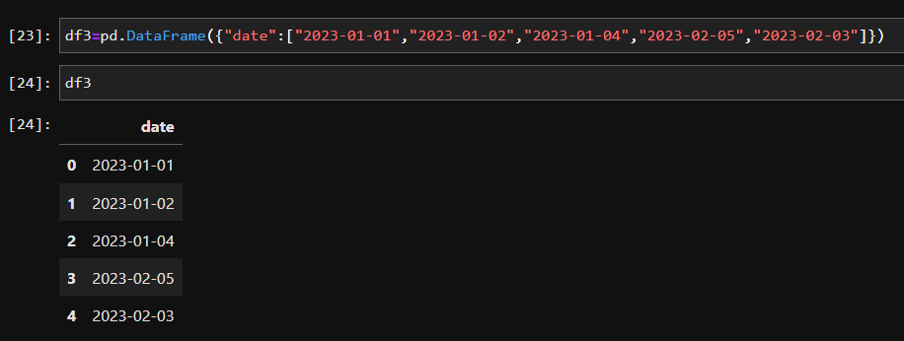

**Time-delta function :- This function is used for calculating the difference between the times and dates**

**For example**

**Categorical :- this is a pandas function which is used for categorizing the values inside the data frame .**

**Also count_values is used for counting the number of categories present in the data ser along with repeated**